Review
Mechanisms of Sweet and Umami Taste Reception
Sofia Floody
Proteins on the tongue detect and interact with a variety of ligands that result in different tasting experiences, important for the evaluation of nutritional value and the enjoyment of food. The sweet and umami tastes bind to taste receptor type 1 proteins, a family of three heterodimeric proteins. These complexes have multiple binding sites across them, accommodating many different ligands. The sweet complex binds natural sugars as well as various other artificial sweeteners. Increased binding affinity correlates to increased sweetness. The most common ligand for the umami complex is L-glutamate, though it has been found that certain small peptides also bind to the complex. The bound conformation of this complex is stabilized by 5’ ribonucleotides, enhancing umami flavor.
Keywords
Taste receptor type 1 (T1R), Venus flytrap domain (VFD), transmembrane domain (TMD), artificial sweeteners, glutamate, ligand recognition
Sweet and umami tastes share receptor proteins
Tasting food is a pivotal part of the human experience, important for both detecting nutritional value, a significant trait in human evolution, allowing primitive humans to find energy-dense foods, and participation of culture, gastronomy being a major aspect to all cultures. Taste buds on the tongue are composed of gustatory cells, or taste receptor cells, that contain the proteins responsible for taste detection. These proteins are the source of taste recognition, binding, and signaling to the brain that a certain flavor is present. There are a couple mechanisms for different tastes: salt and sour are tasted through ion channels, bitter is tasted through the taste receptor type 2 protein, and sweet and umami are tasted through the taste receptor type 1 proteins. Learning about the compounds and proteins that bind to and activate these receptors proteins is important for the future of food and nutrition.
Artificial sweeteners are compounds that bind to the sweet taste receptor complex, yielding a sweet taste, while not containing sugars, and therefore being non-caloric. Although the first artificial sweetener, saccharin, was discovered in the 1800s at Johns Hopkins University, after years of use, many artificial sweeteners lost popularity or were even banned in the US due to studies linking their use with cancer in rats (1). In 2000, this was found to be a unique property in rats, allowing the sweeteners to boom in popularity. Now, you can find sugar-free sodas and zero-calorie sweets in nearly every aisle of the grocery store. Additionally, in this same period, the T1R protein family was discovered, the protein family that is responsible for tasting sweet and umami flavors. Investigation of this line of compounds and this protein family has had a massive effect on the food industry, allowing certain individuals, such as people suffering from diabetes, to enjoy foods they once could not. However, the long-term effects of these compounds are not greatly researched. It is pivotal to learn more about these effects for the safety of the consumer. Studying taste receptor proteins can also introduce other solutions to various food related diseases and ailments. In addition to health benefits, further research can lead to an expansion of foods and flavors.
The Johns Hopkins University Biophysics Department
Sfloody1@jhu.edu
Glossary Terms
Orthosteric site:
Primary binding site on a protein that directly causes a biological effect. The main functional pocket of the protein. This binding will directly cause a response, in the case of taste receptors, the ligand binds, and the taste signal is triggered and sent to the brain.
Non-orthosteric site:
A binding site that is not the primary site, also known as an allosteric site. Ligand binding to this site typically causes a conformational change that can affect the binding to the orthosteric site, either enhancing or inhibiting binding.
Umami was the most recently discovered taste, discovered in 1908 by a Japanese scientist, Dr. Kikunae Ikeda (2). Although the new taste was embraced by the eastern world, the western world refused to accept it for nearly 100 years. The effects of umami ingredients on the human body are vast, ranging from decreased risk of duodenal cancer, reduced salt and fat intake, as well as hepatotoxicity, asthma, migraines, and promotion of obesity (3). With such a wide array of effects, it’s unclear if umami is safe for humans to consume. Further research is imperative to determine long-term effects of umami consumption on health.
Diverse binding sites across domains bind to many ligands
Taste receptor type 1 (T1R) proteins belong to a class C family of G-protein-coupled receptors (GPCRs). There are three T1R proteins, uniquely named T1R1, T1R2, and T1R3. As you can tell from this naming convention, it was a busy time in the realm of food science. These proteins are primarily found in taste buds on the tongues of mammals and other vertebrates, but also exist in nasal epithelium, gut, pancreas, liver, kidney, tested, and brain cells, perhaps alluding to a further purpose past taste recognition (4). These proteins form heterodimeric units that detect sweet and umami tastes: the T1R2/T1R3 complex detects sweet taste, and the T1R1/T1R3 complex detects umami taste. Metabotropic glutamate receptors (mGluRs) are proteins that also belong to the class C family of GPCRs, and as a result, share overall structural and functional similarities, allowing them to be used in simulations to model T1R proteins (5). This has proven to be very useful, as the recently discovered T1R proteins lack ample available models. While many Class C GPCRs form homodimers, T1R proteins form heterodimers. T1R1 and T1R2 require T1R3 coexpression to function. The mechanisms of these heterodimeric formations are not well researched, and there is no evidence that the T1R1/T1R3 and T1R2/T1R3 complexes work as heteromeric complexes, but it is known that they require T1R3, being nonfunctional as homodimers, heterodimers with each other, or monomers. It is theorized that T1R3 could work as a chaperone protein because T1R1 and T1R2 are homes to most ligand binding sites of the complexes and T1R3 seems to have a larger role in signal transduction and recognition (6).
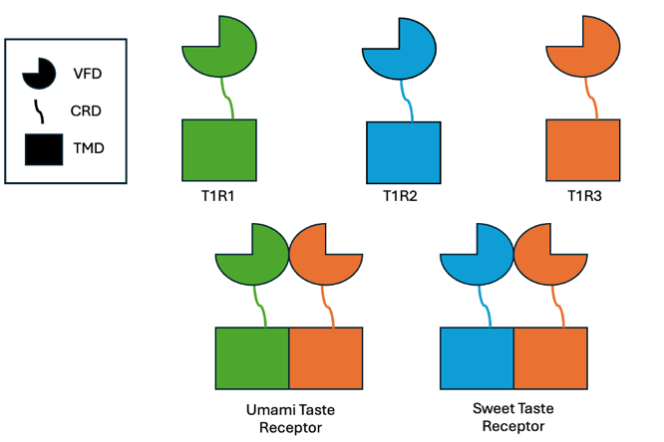
T1R proteins are typically around 850 amino acids long with 3 domains, the Venus flytrap domain (VFD), the transmembrane domain (TMD), and the cysteine rich domain (CRD). The VFD is a large N-terminal extracellular domain, comprising of about 500 amino acids. The binding sites in this region are the primary ligand-binding domains in the taste receptor complexes. The hinge region between the two protein’s VFDs is a common location for binding. The TMD lies on the membrane and is around 300 amino acids long. Although binding is less frequent here, there are various ligands that bind to this region. Both the VFD and TMD regions are comprised of alpha helices, beta sheets, and random coils and have multiple binding sites. The CRD is an extracellular domain that is around 70 amino acids long. This region attaches the VFD to the TMD and is made up of random coils and beta strands (6). The CRD works as a mechanical coupler between the VFD and TMD, responsible for the critical signal transduction between VFDs and TMDs. Closures of the VFDs, indicating a bound ligand, rotates the VFDs. The CRD then transmits a signal to the TMDs, initiating the pathway for cell signaling to the brain. Disulfide bonds in the CRD rigidifies the structure and amplifies mechanical constraints, allowing the region to function like a lever, transmitting VFD movements to the TMD to activate intracellular signaling. This rigidity is pivotal for the detection of low concentrations of ligands, as even small VFD movements can be amplified.
Figure 1: Sweet and umami receptor structure. T1R1, T1R2, and T1R3 have similar structures. The umami taste receptor is shown with the T1R1 and T1R3 proteins forming a heterodimer, and sweet taste receptor is shown with the T1R2 and T1R3 proteins forming a heterodimer.
Most sweeteners bind to the VFD of T1Rs. Experiments involving splicing of VFDs and TMDs of T1R2 and T1R3 of both rats and humans show that that there are a variety of binding pockets in both VFD and TMD. Mutagenesis experiments showed that both VFD and TMD regions are responsible for ligand recognition, corroborating the previous results indicating multiple binding pockets (6). In sweet reception, the TMD region interacts with allosteric modulators and some artificial sweeteners. These compounds and modulators can bind to either the TMD of T1R2 or T1R3 (7).
In the T1R1/T1R3 complex, there are a variety of charges in the binding regions, with specific amino acids being crucial for amino acid recognition, something necessary for ligand binding. These amino acids crucial for recognition are key residues that the protein cannot function without. Six key residues of the human and mouse-type response were found to be responsible for acidic amino acid recognition, with five of these being in the hinge region, indicating the importance of the VFD hinge region in both recognition and binding (8). This ability to recognize amino acids is attributed to properties of the orthosteric ligand binding site.
Sugars and artificial sweeteners bind differently to the sweet taste receptor
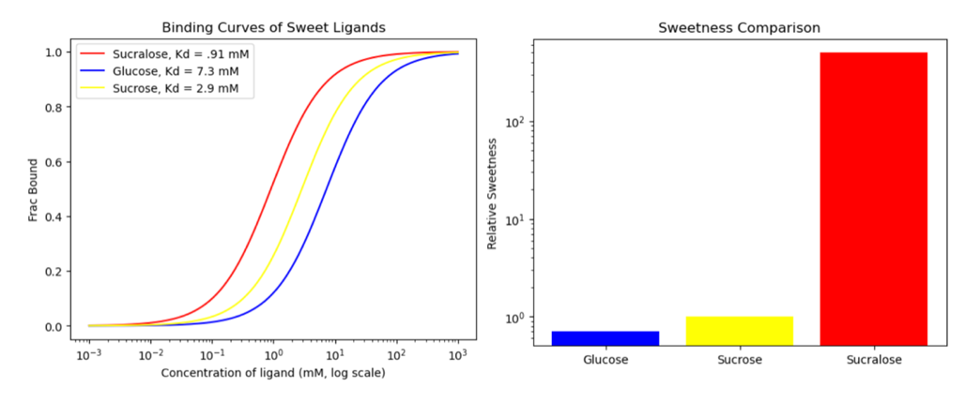
The T1R2/T1R3 complex is a fascinating protein complex that binds to a multitude of ligands, from sugars to various proteins to artificial sweetening compounds. The taste receptor complex T1R2/T1R3 is responsible for determining sweet tastes. Scientists are eager to learn more about the non-caloric artificial sweeteners to find options for sugar-free foods. To do this, they must learn more about sweet taste receptor binding mechanisms.
Figure 2: Inverse relationship between Kd and Sweetness. Binding curves of sucralose, glucose, and sucrose on the left show that sucralose has the lowest Kd value, while also being the sweetest of the three, as seen on the right. The same pattern is witnessed for glucose and sucrose, showing the inverse relationship between Kd and sweetness.
Sugars like glucose and fructose uniquely bind to both the T1R2 and T1R3 VFDs. Additionally, the T1R3 VFD binds with sucrose at a higher affinity than that of glucose, and humans and mice find sucrose to be sweeter. This relationship of higher binding affinity and more prominent sweetness is consistent with other sweeteners as well. This points to a positive relationship between binding affinity and sweetness (9). This relationship is proven true with dissociation constant (Kd) values: there is an inverse relationship between dissociation constants and sweetness (Figure 2). The value of sweetness is found by trained taste panels that compare a sweeteners intensity to sucrose solutions of varying concentration to create a relative sweetness scale. Although there are ways of measuring sugar content, such as using refractometers to measure degrees Brix, the sweetness unit, this is only effective for solutions with sucrose, so it is ineffective in studies like this.
Sugars and artificial sweeteners are intuitive sweet taste ligands; however other more surprising ligands can facilitate sweet taste. Salty flavors are typically the result of NaCl. However, in some cases, when salt is ingested in small doses, a sweet flavor can be detected. It appears Cl- is tasted through the T1Rs, producing a light sweet taste. Experiments show that Cl- is preferably perceived through taste signal transduction mediated by T1R (10). This points to the expansive list of ligands that bind to the sweet taste receptor complex, as well as the sensitivity of the complex, being able to detect very small traces of salt as sweet, when the ion channels cannot detect it as salty.
In addition to Cl-, there are some proteins that bind to the T1R2/T1R3 complex and introduce a sweet taste. A common example is brazzein, the smallest protein sweetener with 54 amino acid residues, found in the Oubli plant in West Africa. Brazzein is 500 times sweeter than sucrose, with a similar taste profile to sucrose. This protein is also stable over a broad pH range and is thermodynamically stable (11). The exact binding mechanisms for brazzein are not known yet, however it is known that the VFDs of T1R2 and T1R3, as well as the CRD of T1R3 are significant to the interaction of brazzein to activate the receptor (12). Thaumatin is another protein sweetener, also a highly sweet protein found in West Africa. While this protein is stable at a wide range of pH values, it denatures at high heats. It has a relatively high cost, especially compared to other artificial sweeteners, so it is not used as commonly in the US. Thaumatin also has a multi-point connection with the T1R2/T1R3 protein complex (13). Because protein sweeteners are larger and interact with more residues of the receptor proteins in different domains compared to other sweeteners, there are many gaps in knowledge about the mechanisms and exact processes in which these proteins activate the receptor, an important facet to be considered in future investigation of this protein complex.
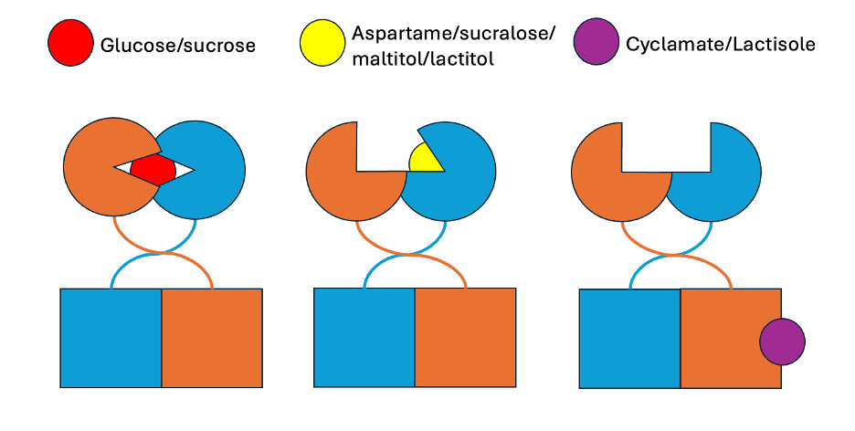
Many sweeteners bind to the VFD of the protein complex. Glucose and sucrose bind to the VFD of both T1R2 and T1R3 (Figure 3). Many artificial sweeteners, such as aspartame and sucralose, bind to the VFD of the T1R2 protein only, resulting in slightly different taste, one that many Diet Coke fans adore. Maltitol and Lactitol, both sugar alcohols, are common sweetening alternatives to sucrose. Binding experiments show that T1R2 is the preferred binding site for maltitol, lactitol, and sucrose (5). Sucrose was found to be the most efficient ligand in this binding. Many ligands were found to be better fit to the T1R2 monomer than the T1R3. Few artificial sweeteners, such as cyclamate, bind to the TMD of T1R3. Cyclamate is an extremely sweet compound, being 200 times sweeter than sucrose. This region of the TMD is a non-orthosteric site, that enhances binding, as well as activating the sweet taste response. Because of this, glucose, sucrose, aspartame, and sucralose could all bind to a VFD while cyclamate is bound to the TMD of T1R3, resulting in an additive sweetness that is stronger than the individual sweetness effects of each ligand. Additionally, modulators can bind to this site. For example, lactisole (not to be confused with lactitol), binds to the TMD of T1R3 and acts as an allosteric inhibitor for both sugars and artificial sweeteners (14). It stops the signal transduction of bound ligands, inhibiting the sweet taste. This gives some insight as to the role of T1R3: T1R3 could be responsible for signal transduction if an inhibitor bound to it can limit the signal from ligands bound to T1R2. The complex holds a multitude of binding sites so that it can accommodate multiple ligands, making it a widely useful heterodimer. Learning more about artificial sweeteners and their interactions with the T1R2/T1R3 complex is pivotal to the future of food.
Figure 3: Ligand binding to the sweet taste receptor. Glucose and sucrose bind to the VFDs of both T1R2 and T1R3. Artificial sweeteners, such as aspartame, sucralose, maltitol, and lactitol, bind to the VFD of T1R2. Cyclamate, another artificial sweetener, and lactisole, an allosteric inhibitor, bind to the TMD of T1R3.
Umami ligand binding is enhanced by 5’ ribonucleotides
The umami taste receptor T1R1/T1R3 is a heterodimeric complex of two G-protein-coupled receptors. The binding site of this complex lies in the VFD in its hinge region. Many ligands bind to the umami taste receptors, with L-glutamate being the first discovered ligand to be shown to provoke the umami taste (Figure 4). 5’ ribonucleotides, such as inosine-5’-monophosphate (IMP) and guanosine 5’-monophosphate (GMP), are known to drastically enhance the umami flavor by stabilizing the ligand-bound form of the VFD of T1R1 (Figure 5). Small peptides are also ligands that bind to the umami taste receptors. Current research suggests that there is a cooperative ligand-binding model, with L-glutamate and other ligands binding close to the hinge region of the VFD in the T1R1 protein and 5’ ribonucleotides binding to an adjacent site near the opening of the VFD to stabilize the closed conformation, causing stronger umami taste. Glutamate binds to the upper lobe of the VFD and lowers the entropic barrier to the closed conformation. The lobes close and facilitate interactions between the upper and lower lobe and between glutamate and the lower lobe. In the closed conformation, electrostatic interactions between the pincer residues stabilize the closed form, enhancing umami flavor (15). This relates to the previous discussion of the direct relationship between binding affinity and flavor intensity. It appears that in both complexes, as ligands are more tightly bound to the protein, the flavor intensity increases, explaining why the stabilizing nature of 5’ ribonucleotides enhances umami flavor. This is an interesting property of the T1R protein family, one that can be utilized in further studies. For example, if sucrose flavor could be enhanced through a stabilizing synergistic modulator, less sucrose would be required for the same amount of sweetness, meaning sugary products would be a little less sugary, making them a little healthier. This same logic can be applied to ligands in both the sweet and umami complexes.
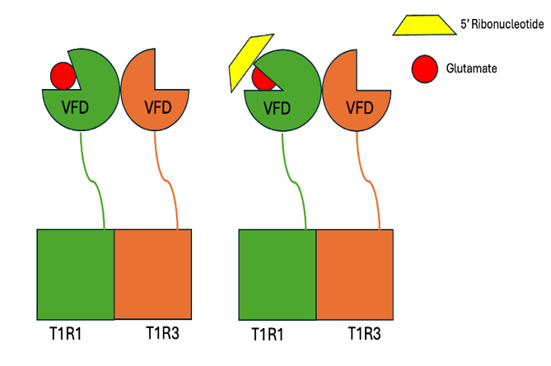
Small peptides of lengths of 2-4 amino acids make up about 40% of umami peptides, the peptides that bind to the taste receptors. Umami peptides can bind to both T1R1 and T1R3, with a strong preference for T1R1. T1R1 is also responsible for detection of umami compounds. The T1R1 pocket has an equal ratio of hydrophobic to hydrophilic amino acids while T1R3 has far more hydrophilic amino acids. In the context of the T1R family, this lines up very well. T1R3 must be able to bind to sugars and therefore must have a high number of hydrophilic amino acids. Meanwhile, T1R1 is solely responsible for umami taste reception, so it can be specialized to the needs of its ligands.
Figure 4: Binding to the umami complex. L-glutamate binds to the VFD of T1R1 in the umami taste receptor, with L-glutamate being represented by a red circle. When 5’ ribonucleotide, represented by a yellow trapezoid, binds to a different binding site of the VFD of T1R1, it stabilizes the closed conformation, increasing binding affinity, enhancing umami flavor.
Peptides most favored by the protein complex were those with at least one hydrophilic amino acid at the N or C terminus. The T1R1 pocket has two regions that enable hydrogen bonds and electrostatic interactions, stabilizing their bonds with peptides. T1R3 has non-binding van der Waals forces facilitating interactions as well as electrostatic interactions. Molecular docking revealed that tetrapeptides typically fold into an “S” shape, with the flexibility enhancing interactions, allowing for more complete binding.
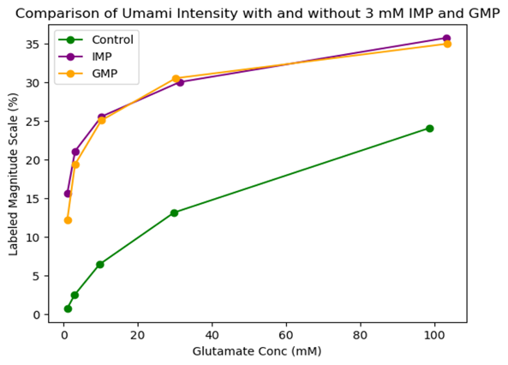
As mentioned previously, there are six key residues in the T1R1 protein that are largely responsible for binding and recognition. It is hypothesized that key residues induce conformational change that affects the association rate of ligands, or that residues affect the signaling capacity after amino acids are bound, explaining why certain residues are responsible for recognition. Results suggest that residues critical for broadly tuned responses modulate receptor activity differently from that of IMP. Point mutants for determinants showed that ligand specificity is determined by two factors, amino acid selectivity and receptor activity, modulated by residues at the non-orthosteric sites (8). These residues can be further studied to determine the required traits for ligands to bind, increasing the scope of compounds that can activate the umami taste.
Figure 5: Effects of 5’ ribonucleotide binding on umami taste. IMP and GMP increase the binding affinity of glutamate, resulting in an increased umami flavor.
As previously mentioned, lactisole and cyclamate bind to the TMD of T1R3 in the sweet taste complex. These ligands are still able to bind to the TMD of T1R3 in the umami taste complex. In the umami taste complex, lactisole maintains its role as a non-orthosteric inhibitor. It blocks the signal pathway, stopping the umami taste from being detected. Cyclamate has the opposite effect. Although cyclamate does not activate the complex itself, as it does in the sweet taste complex, it does enhance the receptors response to the ligand. In comparison to the T1R2/T1R3 complex in which cyclamate works both as an agonist and a synergist, in T1R1/T1R3 it works solely as a synergist (6). This reinforces the thought that the TMD of T1R3 is significant in the signal transduction pathway of the T1R taste reception. In both the sweet and umami complexes, there are synergist and antagonist modulators binding to this site and having similar effects on the signal transduction.
Concluding Remarks
Sweet and umami taste receptors are heterodimers with multiple domains, belonging to the class C T1R family of GPCRs. Their multiple binding sites enable interaction with a broad range of compounds, including orthosteric ligands and allosteric modulators. This broad ligand specificity makes them highly prevalent in daily life.
Sweet taste receptors can bind to sugars, artificial sweeteners, and various proteins, with ligands binding at differing sites to produce varying effects. Ligand binding to orthosteric sites results in sweet taste reception, while binding to non-orthosteric sites can have antagonistic or synergistic effects. While artificial sweeteners are currently widely used, their long-term effects on human health are unknown, and until this is studied further, should be used cautiously by consumers.
Umami taste receptors are even less researched. L-glutamate is the most common ligand, with a variety of short peptides also showing to activate the receptor. 5′-ribonucleotides such as IMP and GMP enhance umami perception by binding to the outer residues of the VFD of T1R1 and stabilizing the closed conformation of the protein, being a valuable compound for umami taste reception. The effects on the human body of umami ligands are diverse, with possible positive and negative effects of consumption.
As research into T1R proteins continues, a deeper understanding of the role and functionality of each protein, as well as their interactions with ligands, is crucial to the future of food enjoyment and food safety. Continued research of sweet and umami receptors is critical for advancing knowledge in nutrition and health.
Highlights
The subunits of the T1R protein all have individual functions in ligand detection and binding, with multiple binding pockets existing in the protein, and with various inhibitors affecting both the umami and the sweet complexes.
The heterodimeric sweet taste receptor complex contains a multitude of domains, with some containing multiple pockets for binding, accounting for the complex binding potential for artificial sweeteners.
Key residues in the VFD of T1R1 help modulate receptor activity, and alongside amino acid selectivity of the complex, yields ligand specificity.
The TMD of T1R3 contains a non-orthosteric binding site that binds to various modulators that affect both the sweet and umami complex.
Outstanding Questions
TMD has been found to be significant to the recognition and binding of ligands, though the exact mechanisms are still to be determined, what role does TMD play?
What are more allosteric modulators for T1R proteins? What domains do they bind to and how do they modulate?
What are the mechanisms between T1R1 and T1R2 that differentiate between sweet and umami compounds?
What are the conformational changes to T1R proteins due to binding?

References
1. Basson AR, Rodriguez-Palacios A, Cominelli F. Artificial Sweeteners: History and New Concepts on Inflammation. Front Nutr. 2021 Sept 24;8:746247.
2. Kurihara K. Umami the Fifth Basic Taste: History of Studies on Receptor Mechanisms and Role as a Food Flavor. BioMed Res Int. 2015;2015:1–10.
3. Zhang Y, Zhang L, Venkitasamy C, Pan Z, Ke H, Guo S, et al. Potential effects of umami ingredients on human health: Pros and cons. Crit Rev Food Sci Nutr. 2020 July 19;60(13):2294–302.
4. Treesukosol Y, Smith KR, Spector AC. The functional role of the T1R family of receptors in sweet taste and feeding. Physiol Behav. 2011 Nov;105(1):14–26.
5. Mahalapbutr P, Lee VS, Rungrotmongkol T. Binding Hotspot and Activation Mechanism of Maltitol and Lactitol toward the Human Sweet Taste Receptor. J Agric Food Chem. 2020 July 29;68(30):7974–83.
6. Xu H, Staszewski L, Tang H, Adler E, Zoller M, Li X. Different functional roles of T1R subunits in the heteromeric taste receptors. Proc Natl Acad Sci. 2004 Sept 28;101(39):14258–63.
7. Hao S, Guthrie B, Kim SK, Balanda S, Kubicek J, Murtaza B, et al. Steviol rebaudiosides bind to four different sites of the human sweet taste receptor (T1R2/T1R3) complex explaining confusing experiments. Commun Chem. 2024 Oct 18;7(1):236.
8. Toda Y, Nakagita T, Hayakawa T, Okada S, Narukawa M, Imai H, et al. Two Distinct Determinants of Ligand Specificity in T1R1/T1R3 (the Umami Taste Receptor). J Biol Chem. 2013 Dec;288(52):36863–77.
9. Nie Y, Vigues S, Hobbs JR, Conn GL, Munger SD. Distinct Contributions of T1R2 and T1R3 Taste Receptor Subunits to the Detection of Sweet Stimuli. Curr Biol. 2005 Nov;15(21):1948–52.
10. Atsumi N, Yasumatsu K, Takashina Y, Ito C, Yasui N, Margolskee RF, et al. Chloride ions evoke taste sensations by binding to the extracellular ligand-binding domain of sweet/umami taste receptors. eLife. 2023 Feb 28;12:e84291.
11. Ming D, Hellekant G. Brazzein, a new high‐potency thermostable sweet protein from Pentadiplandra brazzeana B. FEBS Lett. 1994 Nov 21;355(1):106–8.
12. Assadi-Porter FM, Maillet EL, Radek JT, Quijada J, Markley JL, Max M. Key Amino Acid Residues Involved in Multi-Point Binding Interactions between Brazzein, a Sweet Protein, and the T1R2–T1R3 Human Sweet Receptor. J Mol Biol. 2010 May;398(4):584–99.
13. Temussi PA. Why are sweet proteins sweet? Interaction of brazzein, monellin and thaumatin with the T1R2‐T1R3 receptor. FEBS Lett. 2002 Aug 28;526(1–3):1–4.
14. Jiang P, Cui M, Zhao B, Liu Z, Snyder LA, Benard LMJ, et al. Lactisole Interacts with the Transmembrane Domains of Human T1R3 to Inhibit Sweet Taste. J Biol Chem. 2005 Apr;280(15):15238–46.
15. Zhang F, Klebansky B, Fine RM, Xu H, Pronin A, Liu H, et al. Molecular mechanism for the umami taste synergism. Proc Natl Acad Sci. 2008 Dec 30;105(52):20930–4.

